UNIVERSITY OF SCIENCE AND TECHNOLOGY OF HANOI

**UNDERGRADUATE SCHOOL**



Research and development

**BACHELOR THESIS**

By

Tung Son Vu

Information and Communication Technology

Title:

Android Application Development for Image, Voice and Text Acquisition

Supervisors: Dr. Tran Giang Son

Dr. Bruno Lescalier

Dr. Nghiem Thi Phuong

***ICTLAB, University of Science and Technology of Hanoi***

**Hanoi, July 2016**

Hanoi, September 2013

**Hà Nội, Sept. 2012**

INDEX OF CONTENTS

ACKNOWLEDGEMENTS 2

LIST OF ABBREVIATIONS 3

LIST OF FIGURES 4

ABSTRACT 5

I/ INTRODUCTION 1

II/ MATERIALS AND METHODS 2

**1.** **Technology and Literature Review** 2

**1.1** **Android** 2

**1.2** **Open Street Map** 2

**1.3** **OSMDROID** 3

**1.4** **Mobile atlas creator** 3

**1.5** **Geocoder** 4

**1.6** **Camera** 4

**1.7** **AudioRecord** 4

**1.8** **JSon** 4

**1.9** **GeoJSON** 5

**1.10** **File Transfer Protocol** 6

**2.** **UI Design** 7

**2.2** **First UI Prototype** 7

**2.3** **Second UI Prototype** 7

**2.4** **Third UI Prototype** 8

III/ RESULTS AND DISCUSSION 9

IV/ CONCLUSION 13

REFERENCES 14

# ACKNOWLEDGEMENTS

I would like to express my deep gratitude to my supervisors, Dr. Tran Giang Son, Dr. Bruno Lescalier, Dr. Nghiem Thi Phuong, for their patient guidance, enthusiastic encouragement, and useful comments through out my project. Without their assistance and advices, I would not keep my progress on schedule.

I also would like to thank my teachers, staffs and classmates from University of Science and Technology of Hanoi for the assistance and constant support provided by them on this project.

# LIST OF ABBREVIATIONS

|  |  |
| --- | --- |
| USTH | University of Science and Technology of Hanoi |
| ICT | Information and Communication Technology |
| IDE | Integrated Development Environment |
| SDK | Software Development Kit |
| UI | User Interface |
| OSM | Open Street Map |
| MOBAC | Mobile Atlas Creator |
| JSON | JavaScript Object Notation |
| FTP | File Transfer Protocol |

# LIST OF FIGURES

Figure 1: Google Map (left) and Open Street Map (right) 3

Figure 2: Mobile Atlas Creator Interface 4

Figure 3: First UI Prototype 7

Figure 4: Second UI Prototype 7

Figure 5: Third UI Prototype 8

# ABSTRACT

The work of this project is a part of project SWARMS of the ICTLAB, University of Science and Technology of Hanoi. The purpose of this project is to build an Android application to gather information of place of interests (construction sites, pagoda, etc.). Photos, descriptive voice and text data of the designed places are recorded into Android devices before uploaded to project central server for further analysis. The project is developed by using Android Studio Integrated De Software Development Kit (IDE) and Android Software Development Kit (SDK). The project used Android support libraries: OSMDROID, MOBAC, Apache Commons Net, GeoJSON and native Android libraries: Camera, Geocoder, AudioRecord, JSON to create the application with friendly and convenient User Interface (UI).

# I/ INTRODUCTION

(Global context, literature review, main questions and objectives including the presentation of the problem with the scientific background. Scientific objective of the internship: submit your goal and summarize the strategy in 2-3 concise sentences)

# II/ MATERIALS AND METHODS

## **Technology and Literature Review**

## **Android**

Androidis a mobile operating system (OS), developed by Google, Android is based on the Open Linux Kernel and designed for touch screen mobile and handheld devices. Furthermore, it utilizes a custom virtual machine, designed to optimize memory and hardware resources in a mobile environment. Android also allow developers to create mobile applications, take advantage of all mobile hardware. Application can call any of the phone's core functionality for example: making calls, sending text messages, or using the camera, allowing developers to create best experiences for users.

## **Open Street Map**

OSM is a world online map services and open contents. OSM's purpose is providing geographic data collected from collaborated members around the world. Often called "Wikipedia of maps" with the inspiration of Wikipedia, a website allows collaborative modification its content and structure. The project OSM, held in 2004, mainly to compete with other companies and government agencies which are providing geographic data under strict used terms.

Members contribute data from the GPS receiver, or draw from the air with support application. They upload GPX route data and modified vector data using GIS programs for browsers, desktops, and mobile phones. OSM is also constantly updated through helps of companies, government institutions that often send information of new locations or corrections of the existing ones. This allows the service to have more precise information of places around the world which can be a big advantage while google map focuses mainly big cities.



Figure 1: Google Map (left) and Open Street Map (right)

## **OSMDROID**

OSMDROID library is a Android library included tools and views to interact with OSM. It is a good alternative of Android Google Map tools. OSMDROID helps to build custom MapView, adding custom marker, polyline into MapView. OSMDROID using map tiles to display map. Map tiles are map pictures with different zoom levels. OSMDROID provides tools working with tile providers, loading tiles from offline storage or loading tiles from tiles server. OSMDROID assists offline and online mapping at the same time, loading missing map tiles of offline storage from tiles server for user full map experience.

## **Mobile atlas creator**

Mobile Atlas Creator (MOBAC) is open source program provides offline map tiles for handheld or mobile phone application. OSMDROID offline map tiles could be created by MOBAC, using large number of online maps providers including OSM map provider (MAPNIK, MAPQUEST, etc. ). Maps from MOBAC can be consisted of multiple layers and different map sources and map resolution. Map of specific location, location parameters, zoom level, can be created in user choice.



Figure 2: Mobile Atlas Creator Interface

## **Geocoder**

Geocoder is a class in the Android framework API. Geocoder provides a way to handle geocoding and reverse geocoding. Reverse coding is getting address of the location from coordinate (latitude, longitude). Reverse geocoding information could not be exact location (may contain only city name or full street name of close by building).

## **Camera**

The Camera class is managed to taking the picture, start/stop preview. It is a client for the Camera service, which manages the actual camera hardware. It provides only point and shoot, give no control of how the camera work. This is suitable for the project 's intention, getting information only, not working with raw image capture.

## **AudioRecord**

AudioRecord is a Android class to handle voice recording. The output can be raw audio signal, high quality raw audio file (PCIM). It can be easy implemented and converted into other audio file format (WAV by adding headers or other compressed audio file format MP3, ACC, etc. by wide range of support library). AudioRecord is used to create record of site information with high quality.

## **JSon**

JSon, JavaScript Object Notation, a data format to follow a certain rule that most programming languages are readable. JSON can act as a record database. JSON format is simple and easier to use than other format (XML).

JSON string is enclosed by braces {}. One object started by open bracket { and end with close bracket }. followed by 2 dots mark: and the name / value separated by commas, The key is followed by the value by a colon : and they are put it in double quotes, single quote is not the correct standard JSON string. If there are more data comma use to separate between two objects.

JSON format example

{

{"firstName":"John", "lastName":"Doe"},  
{"firstName":"Anna", "lastName":"Smith"},  
{"firstName":"Peter", "lastName":"Jones"}  
}

One array is one set of values, One array started by open tag [ and ends with the closing tag ]. The values are separated by commas.

JSON Array Example:

{"employees":[  
{"firstName":"John", "lastName":"Doe"},

{"firstName":"Anna", "lastName":"Smith"},  
{"firstName":"Peter", "lastName":"Jones"}  
]}

One value can be one string in double quotes, or one number, or true or false or null, or is 1 object or 1 arrays. These structures could be nesting.

## **GeoJSON**

GeoJSON is a format for encoding geographic data structures. Basically GeoJson follow format but it has their specific key (type, geometry, properties). Type could be Feature geojson object (location) or can be Feature Collection geojson array (locations) which contain of Feature type geojson object. Geometry key is position of the data (Point, MultiPoint, LineString, Polygon, etc). Properties is a json object where user can freely add needed information of the location. The survey form is saved into geojson format.

GeoJson Example:

{ "type": "FeatureCollection",

"features": [

{ "type": "Feature",

"geometry": {"type": "Point", "coordinates": [102.0, 0.5]},

"properties": {"prop0": "value0"}

},

{ "type": "Feature",

"geometry": {

"type": "LineString",

"coordinates": [

[102.0, 0.0], [103.0, 1.0], [104.0, 0.0], [105.0, 1.0]

]

},

"properties": {

"prop0": "value0",

"prop1": 0.0

}

}

]

}

## **File Transfer Protocol**

FTP is a protocol with a set of rules that networked computers use to talk to one another. FTP is the language that computers on a TCP/IP network (internet) use to transfer files to and from each other. The FTP server may support Active and Passive connections. In an Active FTP connection, the client opens a port and listens and the server actively connects to it. In a Passive FTP connection, the server opens a port and listens and the client connects to server through port.

## **UI Design**

## **First UI Prototype**



Figure 3: First UI Prototype

## **Second UI Prototype**



Figure 4: Second UI Prototype

Change from the Fisrt UI Prototype: add introduction wizards where users could get information of the project and require users to add some users information.

## **Third UI Prototype**



Figure 5: Third UI Prototype

Change from the Second UI Prototype: New approach. Second UI Prototype have many buttons, not the best user UI experience. Third UI Prototype uses swipes along with buttons for faster interaction between users and the system.

## **Mockup Using Basamiq**

Basamiq is a mockup tool helping pre-design UI:

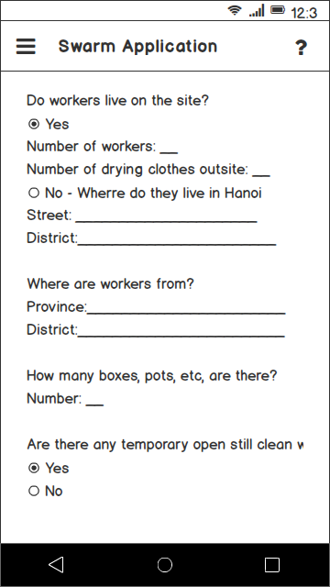 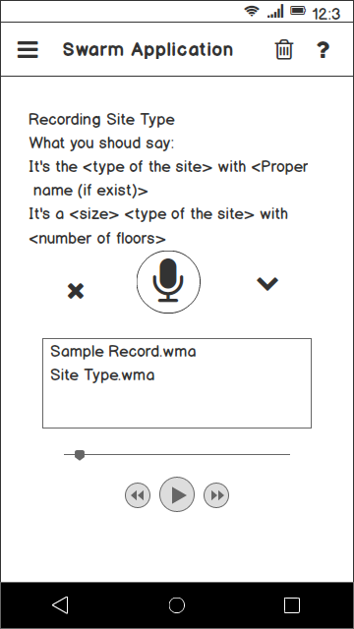

Figure 6: Mockup Using Basamiq

## **Mockup Using Sketch**

Sketch is a mockup tool helping pre-design application UI:

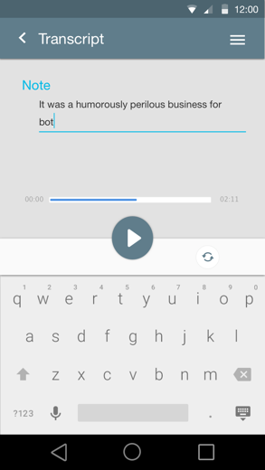

Figure 7: Mockup using Sketch

# III/ RESULTS AND DISCUSSION

# IV/ CONCLUSION

**Conclusion:** the conclusion recapitulates the main achievements of your work and the main perspectives it opens.

# REFERENCES

*References need to be ordered by the alphabet (A → Z). Any cited reference follows the template as followings:*

***In the Text:***All citations in the text should refer to:

1. *Single author:* the author's name (without initials, unless there is ambiguity) and the year of publication;

2. *Two authors:* both authors' names and the year of publication;

3. *Three or more authors:* first author's name followed by 'et al.' and the year of publication.

Citations may be made directly (or parenthetically). Groups of references should be listed first alphabetically, then chronologically.

Examples: 'as demonstrated (Allan, 2000a, 2000b, 1999; Allan and Jones, 1999). Kramer et al. (2010) have recently shown ....'

***In the List:***References should be arranged first alphabetically and then further sorted chronologically if necessary. More than one reference from the same author(s) in the same year must be identified by the letters 'a', 'b', 'c', etc., placed after the year of publication.

*Examples:*

Reference to a journal publication:

Van der Geer, J., Hanraads, J.A.J., Lupton, R.A., 2010. The art of writing a scientific article. J. Sci.Commun. 163, 51–59.

Reference to a book:

Strunk Jr., W., White, E.B., 2000. The Elements of Style, fourth ed. Longman, New York.

Reference to a chapter in an edited book:

Mettam, G.R., Adams, L.B., 2009. How to prepare an electronic version of your article, in: Jones, B.S., Smith , R.Z. (Eds.), Introduction to the Electronic Age. E-Publishing Inc., New York, pp. 281–304.

**Reference management software**

It has standard templates available in key reference management packages EndNote (http://www.endnote.com/support/enstyles.asp) and Reference Manager

(http://refman.com/support/rmstyles.asp).